

INF3014F: External CSS Styling for Tech Gadgets Store Website
Tutorial 3

Due Date: Friday, 13th March 2026 @ 23:59 PM.
Total = 40 marks

Instructions
In tutorial 2, you created a static e-commerce website for an Online Tech Gadget Store using HTML and inline CSS. In this tutorial, you will enhance your website by moving to external CSS and introducing structured styling, layout techniques, and basic interactivity. You aim to create a cohesive, visually pleasing website that appeals to the target audience and meets the website goals. Responsiveness is not required for this tutorial. We will do responsive website design in the next tutorial. No JavaScript will be allowed for this tutorial. The use of JavaScript will incur a 20% penalty

Tasks:

- Review the existing Tech Gadget store website that you created using HTML.
- Identify areas of the website that could benefit from additional styling using CSS. This might include the navigation menu, product listings, or footer.
- Create a CSS file and link it to your existing HTML file.
- Use classes/IDs for styling
- Use external CSS to style the various elements of the website. This might include changing font styles and colours, add background images or colours, or adjusting the website's layout.
- Experiment with different CSS properties and techniques to achieve the desired look and feel for the website.
- Use Flexbox/Grid for product listings
- Add styled navigation with hover effects
- Add a Wishlist: This is a prototype Wishlist. In later tutorials, we’ll make it functional with JavaScript and Local Storage. You can use a predefined list for the user to select.

Interactivity
- Contact Page: HTML5 form with required fields, placeholders, autofocus, and submit button
- Home Page: Add 2 video clips

Best Practices
- Use semantic HTML tags (<header>, <nav>, <main>, <section>, <footer>)
- Add alt text for images
- Comment your CSS and HTML code to explain functionality.
- Maintain a clean folder structure (HTML files, CSS file, images)

Deliverables:
- A separate CSS file containing all of the CSS code you used to style the Tech Gadget Store website. This file should be linked to all pages
- A revised Tech Gadget website version that incorporates your new CSS styling.
- A brief write-up explaining your design choices (colors, fonts, layout) and how they contribute to the website goals and target audience (300-350 words). Your write-up must clearly show the improvements and structural changes made from the last tutorial. Use the Ohio State Framework as a guide to justify your choices, focusing on design and usability.

On Windows OS, use Notepad (or Notepad++) to code the web pages and TextEdit for those with MacOS, and use any browser to view and test your web pages. To start, create a new text document on your desktop and rename it to home.html. You can also use other IDEs like Visual Studio, Sublime or VS Code. However, do follow the instructions below when submitting.

Submit this Tutorial under Assignments (Tutorial 3) on Amathuba.

Finished!

Grading Rubric (Evaluation Criteria):

 | Mark Allocation
- Creativity and originality in design choices. | 5
- Use of external CSS to enhance the website's visual appeal and user-friendliness. | 10
- Consistency in design throughout the website. | 5
- Adherence to website goals and target audience | 5
- Code quality and organization. | 5
- Clear and concise writing that meets all requirements | 10

PLEASE NOTE THAT YOU ARE REQUIRED TO USE YOUR OWN DESIGN HENCE THERE ARE NO DESIGN TEMPLATES. MAKE SURE TO BE CREATIVE.

- Add consistent comments in your code. It helps clarify the code's purpose and functionality for both you and the tutors who will review it.
- Make sure all HTML files and images are in one main folder. Note: You may encounter errors if your images are separated into folders. To be safe, put them all in the same folder as your HTML pages.
- Save your files (e.g., images) with the correct file extensions and zip your folder before submission!
- Do not simply resubmit your Tutorial 2 files without any improvements. We will check.
- Zip all files into one folder and submit them to Amathuba.

Plagiarism Declaration

Disclaimer: AI code generation and completion

We acknowledge the existence of numerous AI code-generation and completion tools currently available. However, we strongly advise against using these tools due to their potential negative impact on the learning experience. These tools tend to reduce opportunities for individuals to develop their coding and problem-solving skills. Therefore, it is highly recommended to avoid relying on AI code generation and completion tools, especially for those just starting to learn to code. It is crucial to take the time to understand coding concepts and principles and practice writing code from scratch to develop one's coding skills fully. You are required to submit a signed AI declaration; failure to do so will result in a mark of 0 awarded. No email submissions will be tolerated, including for those who forgot to attach their declarations.

YOU ARE WARNED TO TAKE PLAGIARISM VERY SERIOUSLY – WE DEFINITELY WILL!

A mark of 0 will be awarded for any submission that does not include a signed Plagiarism Declaration, or for any work that contains content copied from other resources without proper referencing
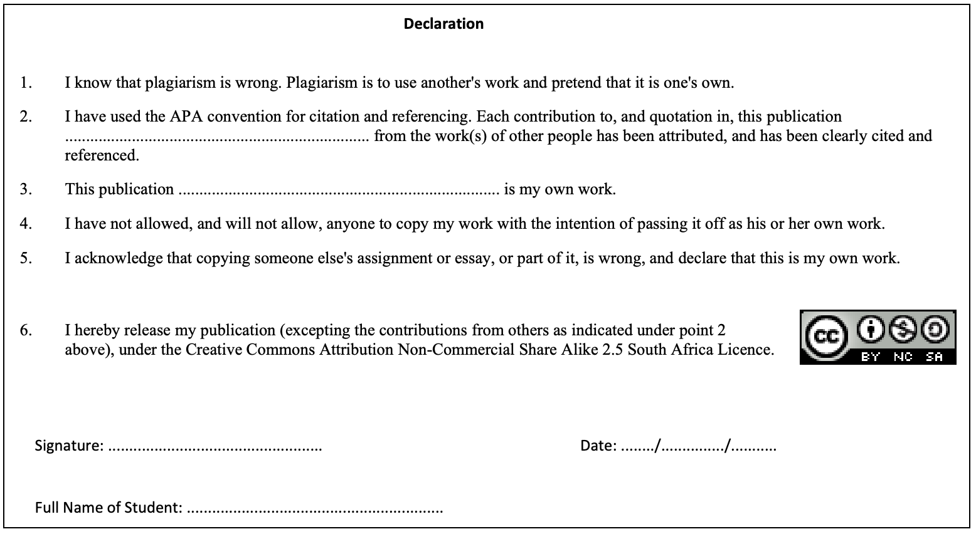

Additional Resources:
- Mozilla Developer Network (MDN) - CSS: MDN is an excellent resource for learning CSS. Their CSS documentation covers everything from basic syntax to advanced topics like layout, typography, and animations. They also provide interactive code examples and exercises to help students practice what they learn.
- W3Schools - CSS: W3Schools is another popular resource for learning CSS. They offer comprehensive tutorials and references for CSS, as well as interactive code editors that allow students to experiment with code in real-time.
- CSS Tricks: CSS Tricks is a popular website that offers articles, tutorials, and resources on CSS. They cover a wide range of topics, from beginner-level CSS to advanced topics like responsive design and CSS frameworks.
-------oo000oo--------

